

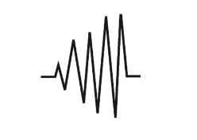




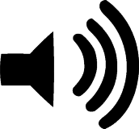


Without Physics we would not know…

- Why there are stars in the sky.
- How to power our phones and computers.
- How to tell the time.
- How we hear things.
- How sounds are made.
- What the different forces are and how these affect us.
- How the world works!

Physics- How matter interacts with energy and forces
Physics is all about Energy, forces and matter. It sounds complicated but we spend our whole lives living with Physics. The force of gravity keeps our feet on the ground and the energy from the sun is what all living things on earth need to survive. When we learn about physics in school we will tackle questions like these ones…

Reception
What can we see, hear and feel while outside?
Can I explore the natural world?

Year 1
What changes are associated with the seasons?
How does day length vary?

Year 2
How can the shapes of some materials be changed?

Year 3
Where does light come from?
How do objects move?
Why is light needed?
What is darkness?
How is light reflected from surfaces?
Why can light from the sun be dangerous and how can we protect ourselves?
How are shadows formed?
How does the size of a shadow change?
How do things move on different surfaces?
How do magnets attract or repel materials?
How can materials be grouped based on their attraction to magnets?
What are the two poles of a magnet?
How do a magnet’s poles affect whether they attract or repel each other?

Year 4
How are sounds made?
How are sounds heard?
What are the patterns between pitch and the features of the object that produced it?
What are the patterns between the volume of a sound and the strength of the vibrations that produced it?
What happens to the volume of a sound as the distance from the source increases?
Which appliances run on electricity?
What are the parts of a simple circuit and how can it be constructed?
What does a switch do and how does it affect a simple circuit?
What are some electrical conductors and insulators?

Year 5
Why do we experience night and day?
How can materials be grouped based on their properties and response to magnets?
What is gravity?
What are the effects of air resistance, water resistance and friction?
How do levels, pulleys and gears allow a smaller force to have a greater effect?
How does the Earth move and other planets move in relation to the Sun?
How does the Moon move in relation to the Earth?
How can the Sun, Earth and Moon be described?
How does the rotation of the Earth explain day and night?

Year 6
How does light travel?
How can objects be seen?
Why do shades have the same shape as the object that cast them?
How do the number and voltage of a cell affect the brightness of a bulb and volume of a buzzer?
How does the position of a switch vary the way a component functions?
What symbols are used to represent components in a circuit diagram?

