Biology- The Study of Life
Biology is the study of living organisms, so in Biology you can expect to learn about trees, plants, animals, seasons and many more living things including us… humans! When we are learning about all these weird and wonderful living things at St Anne’s we will look for answers to some of these questions-

Reception
What can we see, hear and feel?
How are environments different to the one in which I live?
How do the seasons change?
Who are the members of my family and community?

Year 1
What are the names of common plants and trees?
What is the structure of a plant and tree?
What are the names of common animals including fish, amphibians, reptiles, birds and mammals?
Which animals are carnivores, herbivores or omnivores?
What is the structure of common animals?
What are the parts of the human body and which body parts are associated with the senses?
What are the four seasons and how do these change?

Year 2
How do seeds and bulbs grow in to plants?
What do plants need to grow and stay healthy?
Which plants and animals are in my habitat?
What are the differences between things that are living, dead and have never been alive?
How do animals obtain their food from plants and other animals?
Notice that animals including humans have offspring which grow in to adults.
What are the basic needs of animals including humans?
What is the importance of exercise, nutrition and hygiene?

Year 3
What are the functions of different parts of a plant?
What are the requirements for plant life and growth?
How is water transported in plants?
What part do flowers play in the lifecycle of plants?
What nutrients do humans need?
What are the functions or the skeleton and muscles?

Year 4
What are the types and functions of teeth?
What are the parts and functions of the digestive system?
What are different types of habitats?
How can we group living things?
How can classification keys be used to group and identify living things?
How can environments change?
Can we construct food chains and food webs?

Year 5
What are the life processes of reproductions for plants and animals?
What happens to living things over time?
What are the differences in the life cycles of mammals, amphibians, insects and birds?
What changes occur as humans develop to old age?

Year 6
How are living things classified according to common characteristics?
What are the reasons for classifying plants and animals based on these characteristics?
What are the main parts and functions of the human circulatory system?
What is the impact of diet, exercise, drugs and lifestyle on the body’s functions?
How are nutrients and water transported within animals including humans?
How have living things changed over time?
What do fossils tell us about living things from millions of years ago?
How are plants and animals adapted to suit their environment?
How do the offspring of animals including humans vary to their parents?

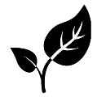
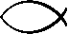
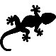
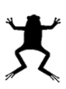


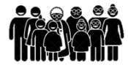
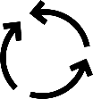
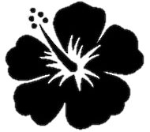

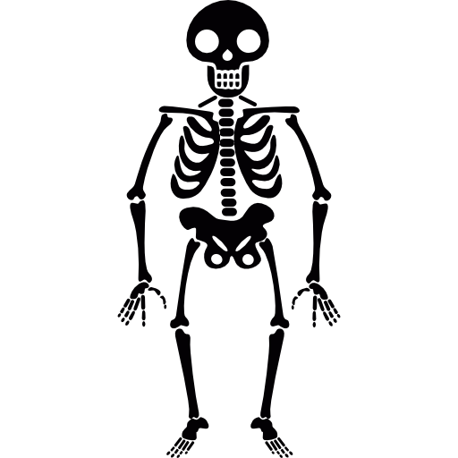
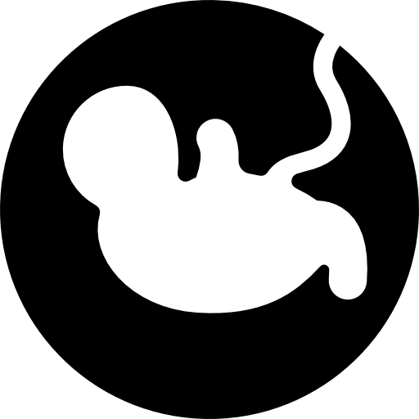
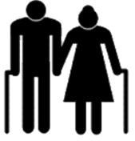
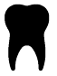
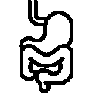
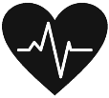
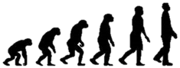

Without biologists we would not know-
- How to heal people when they are sick.

- What is happening inside our bodies.

- How to grow food to put on our plates.

- How to care for the world around us.

