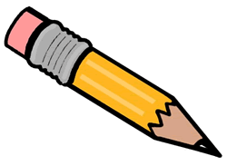
Spelling Activities

Choose one of these activities for your spelling words each day!

Easy as ABC…  Write all your words in alphabetical (ABC) order.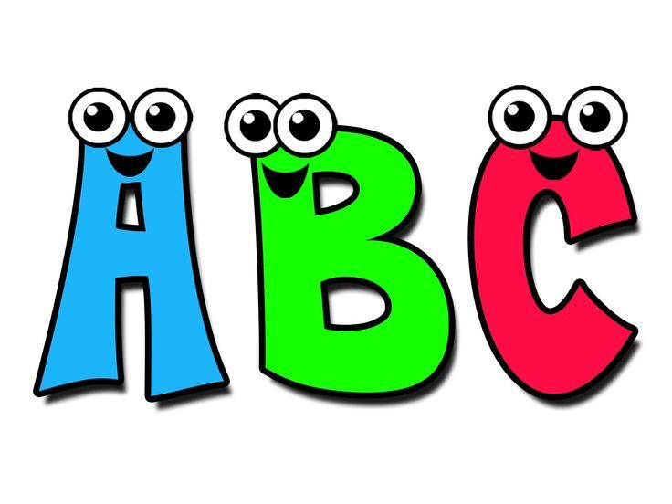 | Part of a whole…  Write your words into different syllables using different colours!  Running  Festival  Brown | On the other hand..  Use the hand you don’t usually write with to practise your spellings!  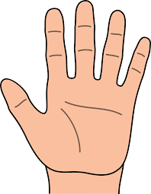 | In the spotlight…  Write the consonants in one colour, vowels in the other.  (Vowels: a, e, i, o, u)  
Like an Egyptian…  Write your word in a p  py  pyr  pyra  pyram  pyrami  pyramid | Your money or…  “Write” words using a newspaper or magazine to cut them out..like a ransom note!  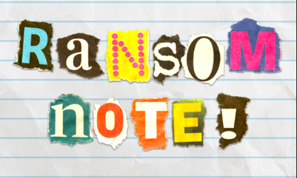 | Come rain or shine…  Write each letter of the word in a different colour to create a rainbow!   | Let’s be silly…  Write a sentence which uses all of your words in it!  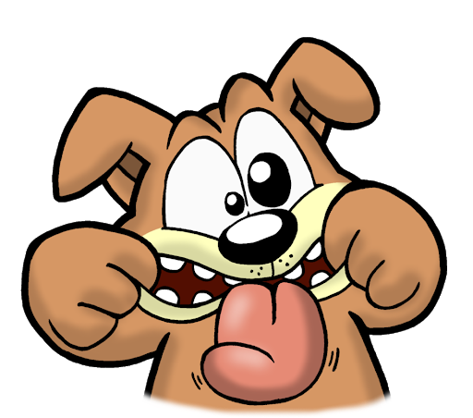
Tell me a story…  Draw a small picture showing your word, then write a sentence about it!   | Blowing bubbles…  Write all your words in bubble writing!   | 20 Questions…  Use half your spellings to write a question...then use the other half to answer them!  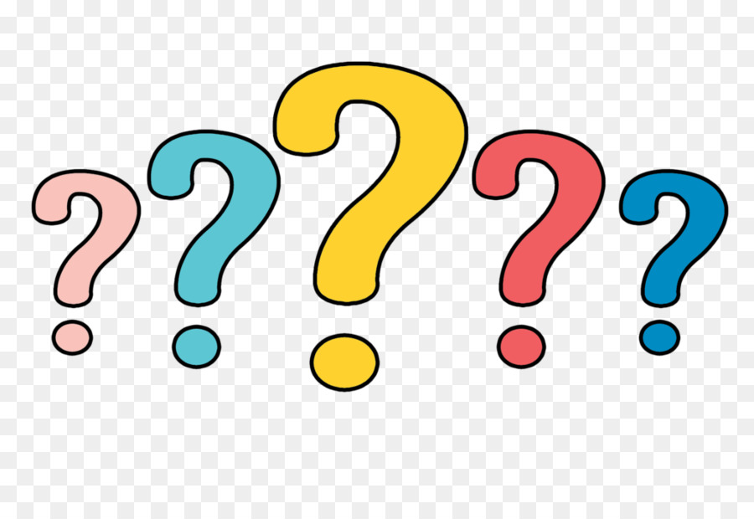 | Rhyme Time…  Write three words which rhyme with each spelling word.  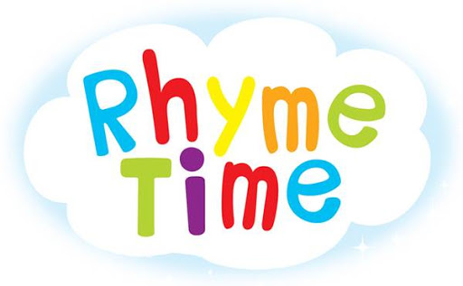
Bond, James Bond…  Create a code. Write your words in the code. Can someone else crack them? | Synonym/Antonym  Synonym - means the same  Antonym - the opposite  Write one of each for each of your words! | That’s backwards…  Write your spelling words backwards!   | You’re a joker…  Write each word into a joke! Test them out on someone nearby…  

