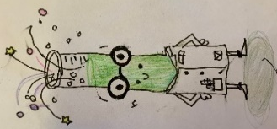
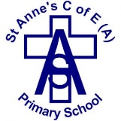
Science teaching and learning at St Anne’s is good when…
We use the correct vocabulary to describe our science thinking.

We are given challenges to deepen our learning.


We ask and answer scientific questions, leading our own investigations applying the knowledge we have learnt.
Our Vision
To foster and develop our pupils’ curiosity in the subject, whilst helping them to fulfil their potential and preparing our pupils for life in an increasingly scientific and technological world.
We work together to answer scientific questions.
We are inspired to explore new things and pursue science in the future.

