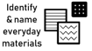
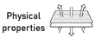
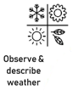
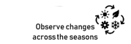
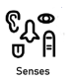
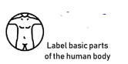
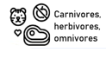
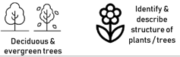
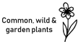
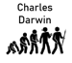
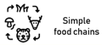
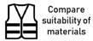
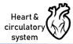
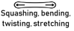
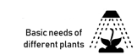

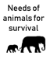
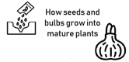
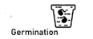
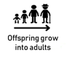
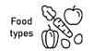
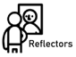



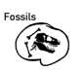
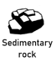
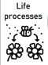
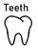
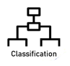
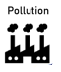
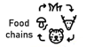
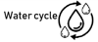

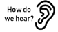

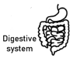
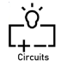



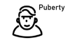
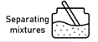
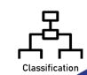
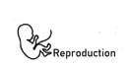
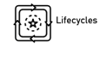
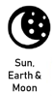
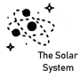



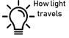
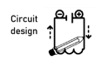
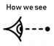
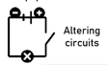
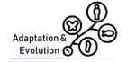
Animals including humans
Muscles and Skeletons 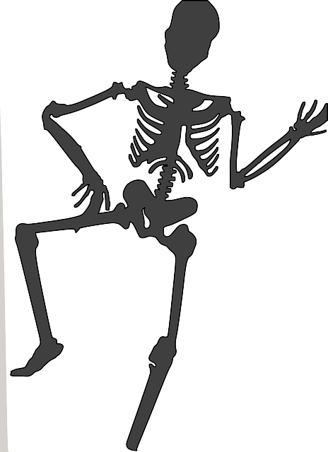
Y6
Living things and their habitats
Evolution and inheritance
Electricity Light
Forces Earth and space
Living things and their habitats
Properties and changes of materials
Animals including humans
Y5
Living things and their habitats
Electricity Sound States of matter
Animals including humans
Y4
Plants Rocks Forces and Magnets Light
Animals including humans
Y3
Living things and their habitats
Plants Uses of everyday materials
Animals including humans
Y2
Plants Everyday materials Seasonal Changes
Animals including humans
Y1
Physical Development (Health and self-care)
Understanding the world
R

