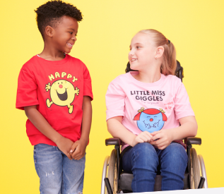
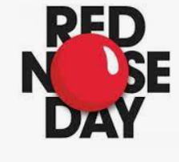

Red Nose Day
Friday 17th March 2023

Red Nose Day is back and we’re all looking forward to joining thousands of people up and down the country to help raise some smiles and money to help people through the toughest times of their lives.

Here’s what we’ve got planned this year …

- Pay £1 and wear something red
Please do not buy something special, a red hair bobble or red socks will do just fine!

- Design a red nose (£1 suggested donation)
Have a go at designing your own red nose. Anything goes be creative!
Prizes for best design in each class will be awarded.
All entries to be in school by 9am on Friday the 17th March for judging please.

This year, we hope to raise as much as we can. However much we raise though, it will change lives, both here in the UK and worldwide.

In fact, £50 could help provide an intensive therapy course for a young disabled person in Malawi and £100 could provide four months of food parcels to a family in South Africa.

We’ll also be using Red Nose Day as a learning opportunity to explore the issues facing young people across the world, and how the money we raise can help.

We really appreciate your support and hope that you’ll have fun helping us raise lots of money for Red Nose Day.

Yours faithfully,

Mrs Knowles and the School Council members.

