
St Anne’s C of E (Aided) Primary School
Harrington Street, Worksop, Nottinghamshire, S80 1NQ. Tel- (01909)473223
Email: office@st-annes.notts.sch.uk Website: www.st-annes.notts.sch.uk
Head Teacher: Mrs C Middleton B.Ed. AG Dip
To develop the whole child; spiritually, mentally and physically in a caring, Christian environment through close links to Church and community.

Dear Parents/Carers and Year 3 children,
Happy New School Year. We hope you have all had a lovely summer holiday and are refreshed and ready for learning.
Daily / Weekly Routines:
- From 8:45am each morning a member of staff is on duty out in the playground. The bell will sound at 8:50am to signal the start of the day.
- Our PE days are on a Monday and Wednesday. On PE days children MUST come to school wearing shorts, a blue St. Anne’s t-shirt (no football kits or coloured tracksuits please) and pumps or trainers. In cooler weather, please provide your child with a navy/black tracksuit (no logos) for outdoor PE. See website for details. Should children be in the wrong PE kit they will be given spare kit to wear for the day. Please note that for health and safety reasons children must remove all jewellery for PE sessions. This includes stud earrings so it is advisable for your child to avoid wearing earrings to school on PE days.

Football at playtimes
If your child wishes to play football on the field, please ensure they have a spare pair of trainers (these can stay in school in a labelled bag) to reduce the amount of grass and mud being brought in to classrooms. Your child will be told which days are their classes football days on the field.
Personal Belongings:
- The children will need to bring a filled water bottle each day. Please ensure that water bottles are labelled with your child’s name.
- A healthy snack can be brought for break time. No nuts - we are a nut free school.
- Please ensure that all items of clothing are named including PE kits and jumpers/cardigans.
- Reading books and reading records will be needed in school every day. They will be used within the classroom for daily reading.
- Maths homework book should be returned weekly with your child’s completed homework with learning log books being due at the end of each half term.

All other equipment will be provided by school so please do not send your child in with any extra items from home such as pencil cases.
Reading
- At St Anne’s, we really value the power of reading. All children will be issued with a reading record, where they will be expected to record the books they have read with an adult’s signature. A remarkable reader is a child who reads at least 4 times a week at home (signed by an adult) to get a stamp in their reading record. After every 5 stamps, children will receive a remarkable reader prize.

Homework

Within Year 3 children will have weekly and half-termly homework tasks. These are designed to consolidate you child’s learning and enable your child to further immerse themselves within their learning at home with their grownups.
- Learning Log tasks – These are linked to our topic area and will be issued at the start of each term in the form of a menu. There is an expectation that three tasks are completed per half term. Learning log tasks allow the children to make choices about the direction of their learning and how they want to present it – Your child will have a menu to stick into their learning log book.
- Spellings –These will be sent home on a Friday every week and your child will be asked to learn spellings involving a particular spelling rule, ready for a weekly test. On occasions, your child will be asked to learn tricky words which do not easily follow a spelling rule/pattern. These words and spelling patterns are taken from the National Curriculum.
- Maths - A piece of maths homework will be set every Friday for Year 3, consolidating an aspect of maths covered during the week. These are to be completed in their yellow maths homework books which should be returned each week to be marked.

If you have any questions please come and speak to us.
Thank you for your continued support,

Miss Burgoyne and Mrs Wilbraham

Within RE we will learn about:
- The people of God
- What it is like to follow God
- Key religious figures
- The trinity
- Our values for this term are: Perseverance and Responsibility
As writers we will:
- Write a narrative
- Write a newspaper report
- Write instructions
- Write a non-chronological report

As historians we will learn about:
- Changes in Britain from the Stone Age to the Iron Age
- Late Neolithic hunter-gatherers and early farmers
- Bronze Age religion, technology and travel
- Iron Age hill forts: tribal kingdoms, farming, art and culture
- Key places such as Skara Brae and Stonehenge
Year 3 Autumn Term Curriculum










As scientists we will learn about:
- The nutrition humans and animals need and where this comes from
- skeletons and muscles and how these are used for support, protection and movement
- working scientifically skills

As mathematicians we will focus on:
- Place Value of 3-digit numbers
- Compare and order numbers up to 1000
- Add and subtract numbers mentally and using formal written methods
- Multiply and divide using mental and written methods
- Solve problems
In PE we will develop our:
- gymnastics knowledge and skills
- invasion games skills
- outdoor and adventurous activities and orienteering skills

This Photo by Unknown Author is licensed under CC BY-NC
As readers we will study the following books:
- Stone Age Boy by Satoshi Kitamura
- Terrible True Tales-The Stone Age by Terry Deary
- How to Wash a Woolly Mammoth by Michelle Robinson and Kate Hindley
- The Stolen Spear by Saviour Pirotta

As linguists we will develop our:
- Phonetic knowledge of French
- Simple words and phrases in French
As artists we will focus on:
- Collage
- Weaving
- Arcimboldo (Artist)
- Overlapping
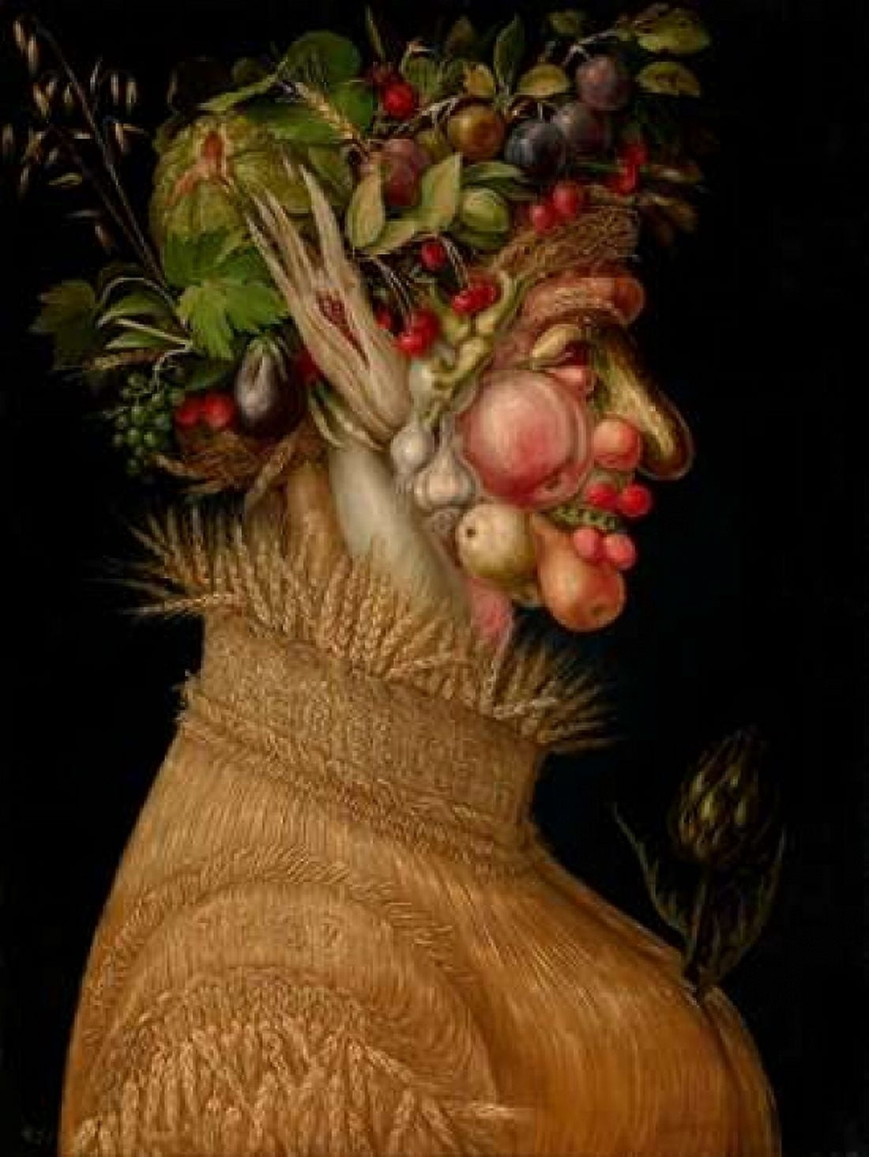

As computer programmers we will learn about:
- Connecting Computers – computing systems and networks
- Creating media – stop frame animation

