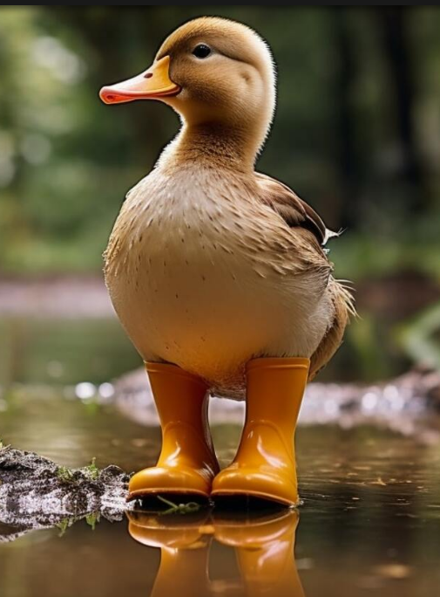

Story starter
As the winter sun bathed the tranquil pond, a small and timid duckling named Percy stood on the bank and watched his feathered friends splashing and frolicking. Unlike his fellow ducklings, Percy despised the sensation of water on his delicate webbed feet and refused to let a single droplet touch them. Instead, he sported a pair of yellow wellies, an unusual choice for a water-loving species, but one that kept his precious feet dry. Despite having developed a reputation as the duckling who refused to take a dip, an undeniable curiosity stirred within Percy's heart. With a deep breath and a determined quack, he decided it was high time he overcame his fear and explored the unknown world beyond the shore...

We cannot wait to see how you use this story starter for your own writing. Remember, you can choose any genre you please. A few ideas might include writing a diary entry, continuing the story, a non-chronological report about ducks or even a set of instructions to help Percy.

Enjoy!

